|  |
| --- |
|  |

|  |
| --- |
| MGMT 6059– Section 01 |
| Term Project – Part 2 |
| Project Management Software Applications |

Group 11

Group Members

|  |  |
| --- | --- |
| Gihan Shamike Liyanage | 1142109 |
| S M Rakibul Basher | 1168369 |
| Maitri Ashwinbhai | 1162874 |

Submitted on: 2023/12/08

2.

1. View a Gantt Chart with WBS as the first column of the Entry Table (zoom your timescale to fit the entire project).

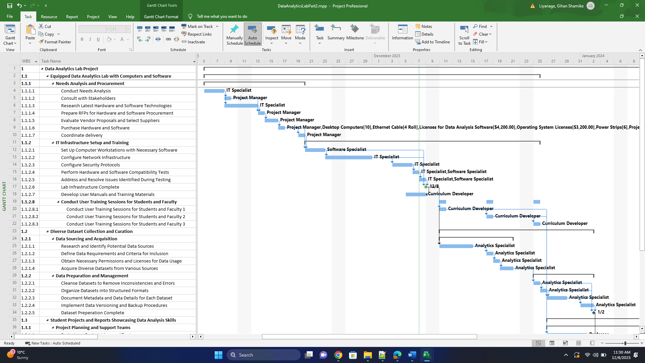

1. Under Calendar View, show the calendar filtered to one resource [only one resource name should be visible], with Task Name, Duration and Resource Name showing on the calendar task bars.

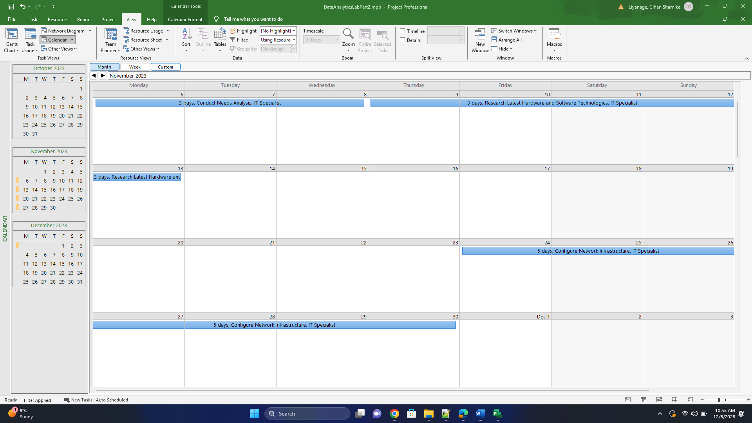

1. View a Gantt chart with [fields:] ID, Task Name, and Start Date. Filter for milestones and include the legend at the bottom of the page. Put the first and last initials of the team members in the legend.

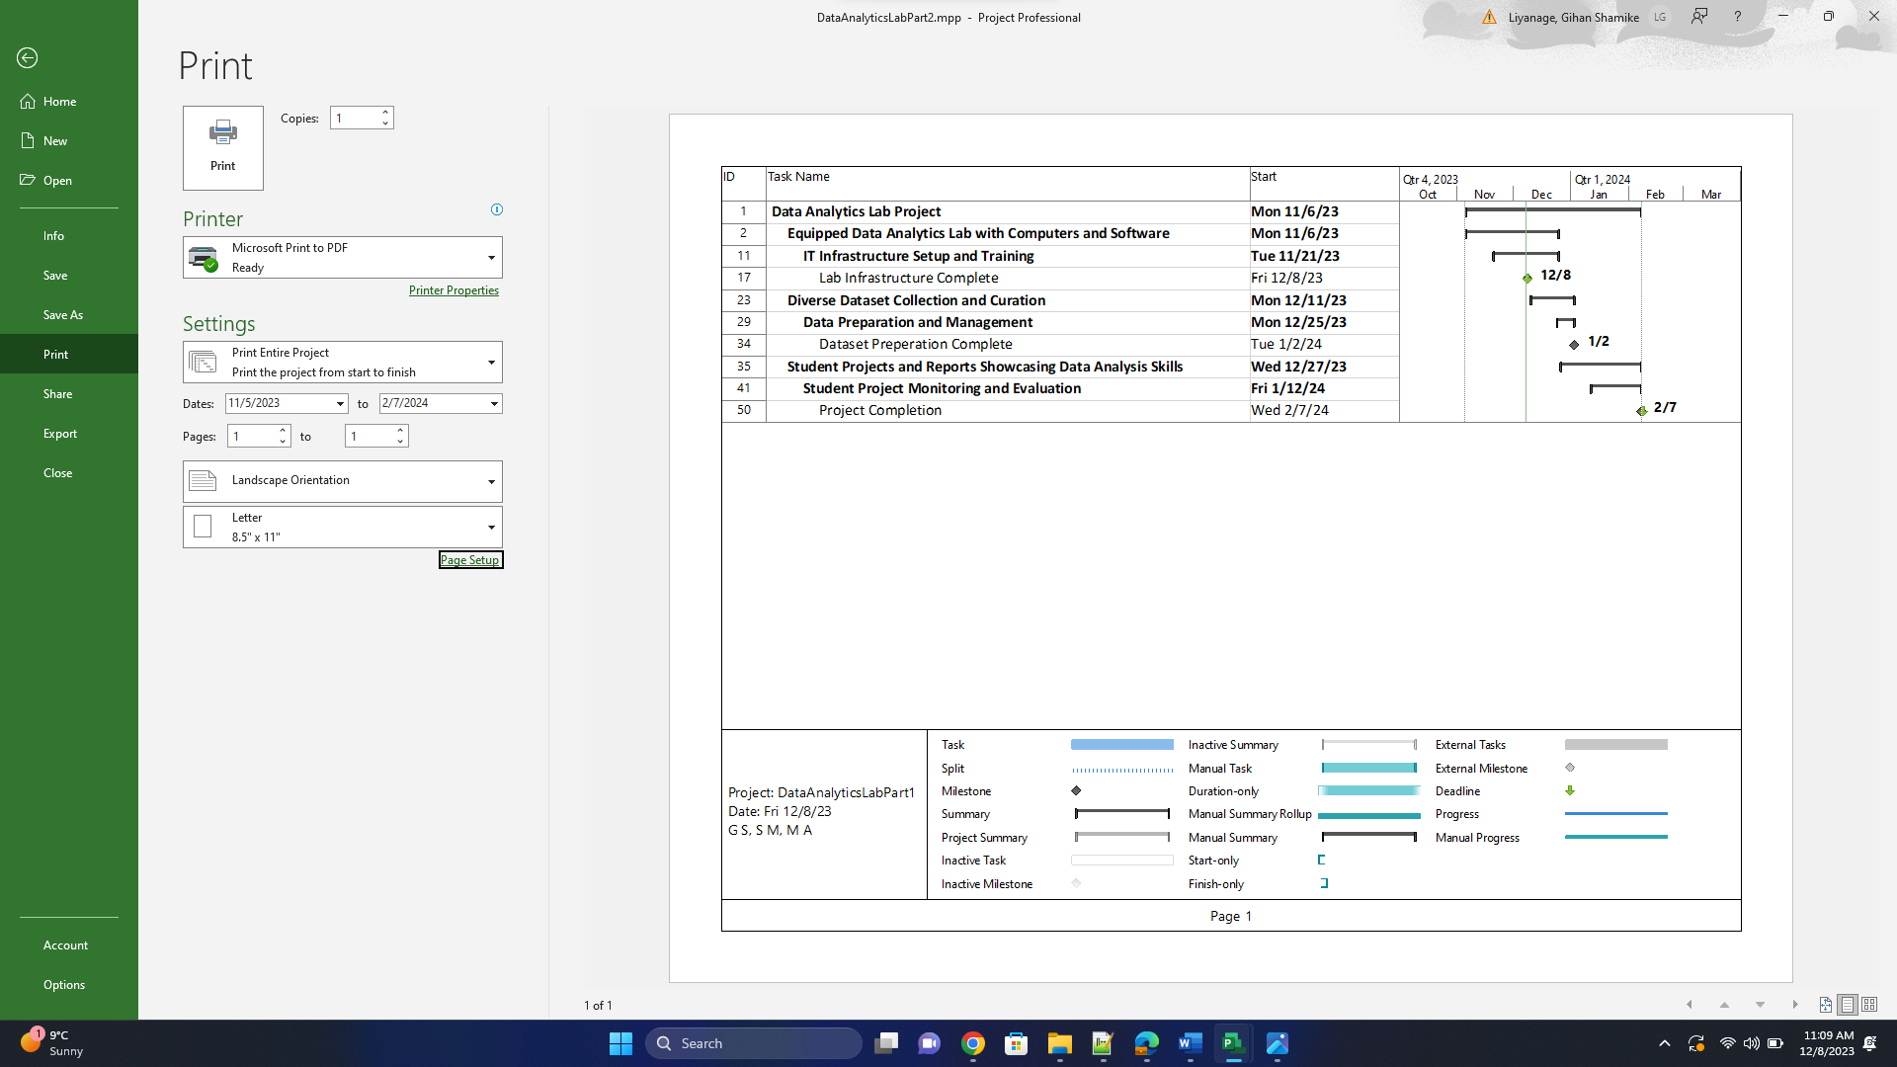

1. View a Network Diagram that is filtered to show only 4 tasks [nothing other than 4 tasks that are Activities with a duration >0 should be visible] - (of your choosing).

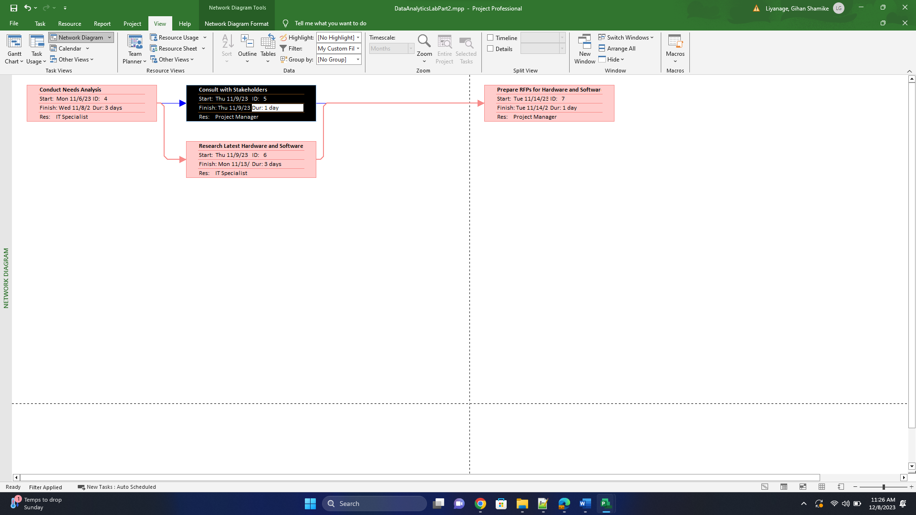

4.

1. Create a built-in report showing TWO Dashboard reports of your choice. Beneath your screen print of your reports, write a one-paragraph interpretation (for each report) of what the report is summarizing about your project.

This report illustrates how much of your project is completed, upcoming milestones, and tasks that are past due, Project total budget, Remaining cost, and cost status.

* According to this 44% of the project has been completed.
* Project completion milestone due is on Wed 2/7/2024.
* In terms of cost, the project has reached almost halfway point.

1. Create a built-in report showing a Resource report of your choice. Beneath your screen print of your report, write a one-paragraph interpretation of what the report is summarizing about your project.

The report shows all the resources in this project along with the amount of work done and remaining in the project. So far, till the status date, no work has been done by the Curriculum Developer in the project. The resource “Professor” has the most work left in his plate summing up to 248 hours. However, the professor has the highest allocated work in the project and has completed about 25 hours’ worth of work.

* Resource project manager use 100%
* Resource IT Specialist used 78%
* Resource Software specialist used 60%
* Resource curriculum developer and Technical support stuff didn’t use yet
* Resource analytics specialist used 70%
* Resource professor used 8%

1. Create a built-in Task Cost Overview report. Beneath your screen print of your report, write a one-paragraph interpretation of what the report is summarizing about your project.

This report shows the overall cost summary of the project. The bar on top right shows the actual cost of the project and the amount of costs that are remaining. The pie chart on the right shows more detailed information. About 50% of the project costs have been spent on the project and $2400 is planned to be spent on the appropriate schedule. About 25% of the costs not spent are allocated for the future but is still on right track time wise. About 22% of the costs are late, meaning it should have already been spent, meaning there are activities that are late in schedule.

1. Create a built-in Critical Task report. Beneath your screen print of your report, write a one-paragraph interpretation of what the report is summarizing about your project.

This chart shows all the critical tasks, tasks that cannot be delayed if the project is to be completed on time. The pie chart on top right shows that about 30% of critical tasks are late, which is alarming as it increases the probability of the report being late. More than 200 hours’ worth of work remain in the critical path and all of them are assigned to one resource. This imposes a threat to the project as any kind of impact to the resource will impact the entire project.

1. A picture of your Gantt chart showing Summary tasks only

We can know that:

* The duration of the whole project
* Can know the summary task duration
* Start and finish date of summery task
* Their percentage of completion of summery task

1. Create an Earned Value Report. Beneath your screen print of your report, write an interpretation of what the report is summarizing about your project.

This chart shows the overall performance of the project from a cost and schedule standpoint. Actual costs, indicated by the blue line, of the project remain below the planned value. This indicates that we have not gone over budget for the project, however earned value indicated by the orange line shows that we have not completed as much as planned in the project, which means that we are behind schedule.

This is further validated by the SPI and CPI charts. SPI remains equal to and below 1. This indicates that we are behind schedule and work planned has been delayed, however CPI remains above 1 so far. Which means that we have accomplished more in terms of cost, meaning we have not gone over budget so far.

1. A Tracking Gantt with ID, Task Name, Duration. Omit the legend at the bottom of the page.

We can know

* The task schedule
* Dependencies of tasks
* Resources allocation
* Critical path
* Completion of task

Team participation For Part 2

|  |  |
| --- | --- |
| Topic | Participator |
| Initial group meeting | All members |
| Modify project | Gihan Shamike Liyanage |
| Create New MS Word File | S M Rakibul Basher |
| Modify Project Further | Maitri Ashwinbhai |
| Final Word Documentation | All Members |
| Final review | All members |